Social Media in the Classroom:
Creating Engaging and Collaborative Learning Environments

Elizabeth Antonyan

Pepperdine University
Master of Arts in Learning Technologies

Thesis Adviser: Dr. Riel

June 2012

TABLE OF CONTENTS

INTRODUCTION TO THE PROBLEM …………………...……………………………………3
PROBLEM CONTEXT ……………………………………………………………………….4 - 8
LITERATURE REVIEW ………………………………………………………………...4
WORK/COMMUNITY CONTEXT ……………………………………………………..8
RESEARCH DESIGN …………………………………………………………………………..10
CYCLE ONE ………………………………………………………………...…………….11 – 19
RESEARCH QUESTION ……………………………………………………………….11
ACTIONS ……………………………………………………………………………….11
EVIDENCE ………………………...……………………………………………………14
EVALUATION ………………………………………………………………………….17
REFLECTION …………………………………………………………………………..19
CYCLE TWO ……………………………………………………………………………...21 – 26
RESEARCH QUESTION ………………………………………………………………21
ACTIONS ……………………………………………………………………………….21
EVIDENCE ……………………………………………………………………………...22
EVALUATION ………………………………………………………………………….23
REFLECTION …………………………………………………………………………..25
CYCLE THREE ……………………………………………………………………………27 - 35
RESEARCH QUESTION ……………………………………………………………….27
ACTIONS …………………………………………………………………………….…27
EVIDENCE ……………………………………………………………………………...28
EVALUATION ……………………………………………………………………….…32
REFLECTION ………………………………………………………………………..…34
FINAL REFLECTIONS ………………………………………………………………………...36
REFERENCES ……………………………………………………………………………….…38

INTRODUCTION TO THE PROBLEM

“Good morning Mrs. Smith.”

“Good morning children. Have a seat. Today we are going to learn about…”

How many times have we heard a similar kind of dialogue between teacher and students? Whether it be from our own personal experience, from watching a movie or show, or even reading about it in a novel set in the 1900s, or even in 2012. Today, classrooms pretty much look, feel, and function just as they did 100 years ago. Over the years, theories have changed, learning styles have evolved, and countless teachers have tried a variety of different ways to connect to students. Some have succeeded in unconventional ways, and some have unfortunately failed. However, the fact remains that a majority of classrooms, students, and teachers, still function the same way they always have.

This fact is a fairly odd occurrence because times change so rapidly with the aid of technology or even as a result of technology. People, styles, work habits, businesses, and so much more constantly and consistently change over time. However, the way we educate our children, our future, that has not seemed to change much.

This obvious oversight is not only hard to understand, but it should be unacceptable. During a time when technology is changing at its most rapid pace, children, students, even adults have changed how they perceive things, absorb information, and communicate. There has never been a time in history when information has been able to be transmitted almost instantaneously to a mass media. Through innovations and inventions like the internet, email, social media sites, hand held smart phones, transmission of communication has not only changed in its pace, but in its form altogether.

To not harness the power of this kind technology would not only be a shame, it would be ignorant of us to ignore it away as most people usually do with things that are unconventional. Times are not only changing, they have changed. As a result, we need to change with it.

Today, social media is all the craze. People use social media daily to post their thoughts, plans, ideas, pictures, stories, and more. Other people respond to these posts in great haste. People have a lot to say, and for some reason, they feel comfortable saying it in public forums like Facebook, Instagam, and Twitter. To employ the power of social media into the classroom only seems like the obvious next step.

The overall goal of my Action Research is to test if and how social media can play a role in the classroom to engage students, encourage collaboration, and create a higher level of accountability among students and their work.

LITERATURE REVIEW
A Collaborative and Engaging Learning Environment Through the Use of Social Media

Research, articles, blogs, and other forms of communication have stated over the past few years the significance and the importance of the role of technology-supported cooperative learning such as social media in learning communities. Whether these learning communities are in the work place, project based environments, the classroom, or other forms of learning environments; social media has played a role in facilitating the implementation of the lesson, information, and education of the material (Davidove, 2010).

Wikis, social media sites, clouds, and other new technologies all revolve around the idea of collaboration, sharing of ideas, and peer-to-peer interaction. One can classify this phenomenon as a trend, or one can look at collaborative settings as a result of a need to communicate, learn, and innovate together. Tsay and Brady (2010) note that the very nature of cooperative learning is changing as social media outlets like Wikis and Facebook become widespread. Wikipedia defines social media as “the use of web-based and mobile technologies to turn communication into an interactive dialogue”; much like Wikipedia seems to have established itself as an interactive communal forum of information.

This suggests that technology has provided the ability to collaborate and therefore lends itself to cooperative learning. It seems the purpose of technology in education “before the 1990’s used to be based on the single-learner assumption. The individual assumption is that instruction should be tailored to each student’s personal aptitude, learning style, personality, characteristics, motivation and needs ” (D. Johnson & R. Johnson, 2007: 403). As times change, so do the needs of people and organizations. Today, the ‘single-learner’ approach does not seem to apply to a quickly changing, technology heavy population. Social and collaborative opportunities that are readily available through technology, learning, and teaching have enabled the “single-learner” to broaden his or her communication scope in order to approach learning in a collaborative way.

The ultimate goal in any learning environment is to provide effective and useful learning opportunities. Communication, or at least, the transmission of communication is key in establishing an effective learning environment. Dewey (1922) states that society continues to exist because of the transmission of communication from one generation to another. Upholding and maintaining the flow of communication is an important factor in learning from one another.

Social media has been used as a tool in creating a forum for communication and a platform for sharing ideas. In an article from Harvard Business Review, Bradley & McDonald (2011) define social media as “how my peers show me what they think is important, based on their experience and in a way that I can judge for myself.” More popular social media networks like Facebook, Twitter, and LinkedIn are used everyday for communicating personal and professional information to peers and “followers” alike. Through posts, followings, invites, and threads of communication, people learn every day. They learn about a fundraiser organized for the weekend; they learn about their favorite stars; they learn about what their friends did yesterday; and so on. If people are learning various types of information through this kind of casual learning, then they can learn any kind of information from each other – socially.

The presence of social media and its integration into the lives of people today is not only evident, but also constantly increasing. Wikipedia has evolved into an online encyclopedia that rivals traditional forms of reference for the masses; LinkedIn serves as a credible substitute for
networking and sending out resumes; and Facebook has exponentially replaced the need for phone calls, holiday cards, initiations, and so much more. Through these and other forums of social media, the way we communicate and the way we acquire knowledge is not only evolving, but has already changed, and as a result is changing how people perceive and approach learning. (Davidove, 2010:p) Social media’s presence and influence is undeniable. People receive information in a variety of ways by engaging through social media. The potential and impact social media has can greatly contribute to learning, collaboratively and productively.

Importance of Social and Collaborative Learning

Since the beginning of time, people have acquired knowledge in a variety of ways. Language through parents; habits through siblings and friends; grammar, arithmetic, and sciences through teachers; skills through trained masters; mankind has evolved and thrived because of their ability to learn.

But what is learning, and what is the most effective manner to engage in it? According to Frank Smith (1998), there are two views of learning and forgetting – the classic and the official view. The classic view says, “We learn from people around us with whom we identify” (p. 11). It is continual, effortless, boundless, vicarious, a social activity, and never forgotten. The classic view incorporates the kind of learning we do everyday, without much effort. Most times, individuals are not even aware that they are learning something. They are so engaged in the lesson, project, or activity that they learn without realizing it is being done. On the contrary, the official view states, learning is work, and that anything can be learned provided sufficient effort is expended and sufficient control enforced. Official learning is occasional, limited, based on effort, memorization, individualistic, and easily forgotten. When individuals learn the official way, they are very cognizant of the process of learning. The process of learning is quite intentional and a difficult task. It is work; it is hard; and soon after the information is used for its purpose, it is usually forgotten because there was no real engagement or involvement in the process of learning.

If Smith is correct in these assertions, it is hard to understand why the official view of learning has come to dominate the activity of schools. Most classrooms, teachers, and students engage in practices that Smith describes as the official view of learning and forgetting. Many students are part of a classroom with a teacher ready to learn, in what may appear to be a collaborative setting. There are groups of students and spaces, which might support collaboration. However from my experience, collaboration in classrooms is not the norm. If we learn from those around us with whom we identify, then why are students not learning from one another in the classroom? One reason can be that collaborative learning is not taking place among peers. It is learning structured by the teacher to the student, information and style of implementation decided for the student. Teachers have set clear boundaries and rules that students are expected to follow to succeed. And if one veers off the limits of the set boundaries then failure is sure to follow. Very rarely does learning happen from each other in the classroom because the classroom is not set up in that way.

According to Smith (1998), the classroom should be more like a club where students learn from one another as well as from the teachers. Once you are a member and discover what activities are available to you, more experienced members help you to do things that interest you. They do not teach you; they help you. There is no coercion, nor are there great expectations. No one cares how good you are; you are simply accepted for who you are – a member of a club –
and are helped to do what you are interested in doing. You gain security and confidence (1998:18).

It is the setting, the surrounding, and the people we spend time with that fosters learning or the want to learn. Smith says that useful learning occurs during our daily life, not when we take time out from it. Learning happens whether we are ready for it or even aware of it. (p. 13). Learning done for the sake of learning is easily and quickly forgotten. Most learning that is done as a result of hard work is soon forgotten because of the lack of connection and invested interest in the subject or topic.

Learning integrated with other activities as part of one’s regular day, tends to stay with one longer and more effectively. Today’s daily life revolves around social media. Posting on Facebook and tweeting for example, take up most of people’s days on the computer, smart phones, tablets, etc. Our every day lives are engrossed in technology. Communication through technology, specifically through social media, has created a platform for possible engagement, peer-to-peer learning, and education. However, the possibility is not enough, there have to be willing participants to engage in learning. Individuals who participate in social media are usually willing and choose to log on and participate. As a result of this willingness, they will benefit from these possibilities because there is no coercion for them to participate, nor boundaries limiting their extent of participation.

Social Media enables people to break down conventional communication barriers that keep people isolated; thus, preventing them from learning socially or collaboratively. Groups of people have used social media to establish a free forum of communication that extends to people who have access to the technology. By breaking down communication barriers, a new kind of learning has been established, a technology-supported cooperative learning environment. The very nature of technology-supported cooperative learning depends upon social activity and participation. The learners, or members of the group are there voluntarily to share, learn, and communicate about a subject or topic. It is because of their voluntary presence and participation that learning is able to happen in a productive environment. The Khan Academy is a prime example of such voluntary medium. It is a site with over 2,700 videos covering various types of lessons and practice exercises. People visit the site to learn something voluntarily and get feedback through the use of badges that encourage the learners to continue learning and visiting the site. The sense of belonging is key to learning, because it promotes confidence, ease and comfort in sharing, and can create an atmosphere of positive feedback and learning.

Implementation of Social and Collaborative Learning

Learning through social media can help enhance the learning process; however, there is no one or best way to implement this kind of technology-based cooperative learning into classrooms and curriculum. The way technology, social media, various software and hardware have been used for learning will vary among groups, social atmospheres, learning purposes, and so on. The type of technology used is not necessarily the key factor, but the way it is integrated and utilized in the learning process. Most importantly there needs to be a strategy in place that “should integrate social learning into the mainstream of the organization by aligning it to important goals” (Davidove, 2010). For example, classrooms can use wikis for a collaborative project or a social media site like Edmodo for communication and feedback for assignments. By establishing a set plan for integration of technology, social media becomes the main avenue of communication and learning to achieve the greater good for the organization.

By establishing social media as possible method to accomplish said goals, educators can effectively use social media to achieve their goals – educating and engaging students. Technology becomes one of the vehicles used to accomplish the goal of learning. Smith (1998) warns us of the “dangers” of technology and paints an almost Fahrenheit 451- kind of picture of how technology will eventually make humans or human need obsolete. While that can be a possibility, it does not have to be. On the contrary, technology based practice has demonstrated how human centered design, learning, and engagement requires the input of many people, working together. ”Educators must recognize the potential for improving student engagement in the classroom using these technologies” (Holland and Muilenburg, 2011). If teachers embrace technology, use it to enhance their teaching, not replace it, and embrace all the positive components it has to offer, subsequently a more productive and collaborative learning environment should be established. By creating the opportunity for students to learn what they are interested in or making the learning far more engaging through social media, educators have created an environment where students are learning in the way Smith (1998) says we learn and remember best.

Summary and Conclusions

The presence and influence of social media has taken hold and is an undeniable part of our lives today. People encounter technology in their daily lives and acquire experiences as a result of it. People have already accustomed themselves to learning through technology, through social interaction, and most importantly through a collaborative setting. They communicate with each other, in groups, both synchronously and asynchronously for various reasons.

They key is to learn from each other and through each other’s experiences; but more importantly, the key is to establish a sort of culture where people can choose to join and participate in each other’s learning. Social media provides a forum for this kind of sharing of experiences and knowledge in an instant kind of medium, taking advantage of the technologies and cultural norms that are available to us today.

MY WORK/COMMUNITY CONTEXT

I have to start off my work/community context with the word “Pilibostzi”. I know this does not make sense to anyone, so let me explain. Pilibos is the name of the school I work in and the suffix “tzi” is Armenian. You add it to any word to imply membership or belonging to a group of some sort. So when I say “Pilibostzi” I mean that not only do I feel like I belong to the school I work in, but I feel as if Pilibos IS MY school.

My history with Pilibos began in 1979. My parents and I had just emigrated from Armenia into America, what seemed like a strange and foreign land. My parents had fled from a country overrun by Communism and corruption in hopes of providing a brighter and better future for me, their only child. As they were trying to acclimate themselves to this new land, new culture, and new life, one thing was certain, they were going to send me to an Armenian School, no matter the cost, so I may hold on to my Armenian roots as best I could in this foreign land. And so my education began at Pilibos as I entered Kindergarten. The school quickly became my second home; a place I felt safe and knew would be there for me when I needed it.

It was right there and then in 1979 that I became a Pilibostzi. As a result, when I returned to Pilibos to work as a teacher, I knew that after all those years; it was my turn to give back. And ever since then, I have been working as a Teacher, Mentor, and Director of Administration and Outreach. Having those titles however, has not limited my scope of work. Everything I do in that school I do with love and much enthusiasm. I relish in taking on any job, duty, or task, as long as I know it is somehow benefiting the students of Pilibos.

Pilibos is located in the heart of Hollywood, in the “Little Armenia” district. It is one of six Prelacy schools under the Western Armenian Apostolic Church. And as of this year, it is one of the only two schools among the six that is K-12.

At one point, the school consisted of 800+ students that resided anywhere from the neighboring communities in Hollywood to communities that were up to 10-15 miles away. However, these days because of more choices and increase in traffic, the population has dwindled down to about 550 students, most of who are from the immediate areas surrounding the school. That translates to kids from lower income families, who most of the time cannot pay their tuition (which translates into an almost non-existent budget), and families who themselves are not educated and cannot truly help their children with their studies.

I work in the main office of our school. It is a pretty small campus with two main buildings for classrooms, a gym, and a library. The people who work in the office are myself, the receptionist, the accountant, the Dean of Students and the Principal. It is safe to say we are a pretty tight knit group. Right in front of my office door is the door that leads to the teacher’s room. So whenever someone from the faculty room walks into the office, I am the first person they see, and the first person they approach with their issues. I am usually very receptive to any and all of their questions. I love being able to help them with their schedules, deadlines, understanding how to complete a task, etc.

The faculty is made up of a mix of Armenian and non-Armenian teachers, young and old, male and female. However, despite the variety of teachers, an “old-school” kind of culture seems to prevail. Most teachers are very accustomed to doing things a certain way, their way. When a new program is introduced most are pretty resistant to accepting a change. Sometimes I find myself in the same predicament… “but that’s not how we do it”. Stepping outside of one’s comfort zone is not something that is expected, done, or even appreciated by most. But some forward thinkers do accept it and make an effort. I believe we are stuck in a culture of ‘how things used to be’. I truly hope however, that through the work I have done in my Action Research, we can move out of that kind of thinking into a culture of ‘how things can be’!

As Director of Administration and Outreach it is my goal to get our school to a place of forward thinking and moving toward change. I am lucky enough to work for an Administration who is open to change and willing to take risks for the benefit of students. It is because of this Administration that I was able to also teach a Digital Media class to the sophomores and juniors this year. I based my Action Research on this class incorporating social media into our curriculum.

Everything I do at the school is done, not because it is my job, but because I truly, wholeheartedly want to do it. I want to help my school flourish, my students succeed, my teachers evolve, and my school to be not one of, but the best school of its kind. There is surely a long road ahead. The future holds many changes in curriculum, staff, procedure, use and integration of technology, etc. However, I believe all the work and effort will ultimately bring about the kind of change the school and its students are worthy of.

RESEARCH DESIGN

Action Research is a cyclical process that puts you the researcher at the center of the action research. Action research involves the key steps of planning, acting, observing, analyzing, and reflecting. Upon reflection of the first cycle, the action researcher can devise a new action plan based on reflection and findings of the first cycle. Action researchers repeat these steps for continual progression and improvement in his/her workplace and/or environment.

In designing my Action Research on social media in the classroom, I had to decide on what were key factors for me and how I planned on making the changes that I perceived necessary. I wanted to understand and experience if and how social media could make a difference in the classroom in how the students utilized its power to leverage their learning, communicating, and contributing to the class. I wanted to take this opportunity to make a change, a real change, a sort of evolution in my workplace, for the better.
To pull this off, I had to employ the help of my students. They were not the subjects, but part of the research. My Action Research was a joint venture between my students and myself and the progression of the new Digital Media class. We went through the steps of gathering data, analyzing it, planning action, taking action, evaluating action, etc… jointly. They were not always aware that they were doing these things, but all members of the class were part of the research as sort of stakeholders in the action research.

RESEARCH QUESTION
How do I improve student engagement and accountability in the classroom using social media as the main form of communication and collaboration?

CYCLE ONE

How will the integration of Edmodo in the class as a forum for me to administer assignments, collect assignments, administer grades, and spark discussions and questions among students affect their interest in the class and their level of accountability and performance?

ACTION:

This year, I created an elective class called Digital Media. In this class, I planned to explore different kinds of technology such as video, online news resources, social networking, blogs, photos, podcasts, music, etc. Figure 1.1 is the syllabus for this class.

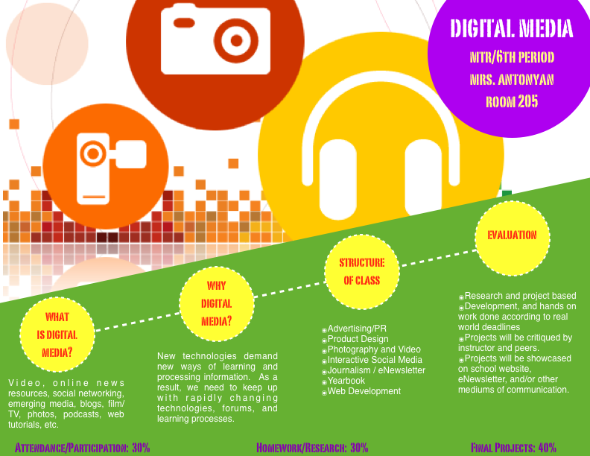
FIGURE 1.1 Syllabus for Digital Media Class

My goal was to integrate Edmodo, a form of social media, as the main communication and management tool for teaching this class. In order to do this properly, I approached it in incremental steps.

- Step 1: I took a survey of my students. Out of 24 students in my class, 22 of them had a Facebook and/or Twitter account, and some of them also had Tumblr and Instagram accounts as well. I then asked how often they use one or all of these accounts. Table 1.1 depicts how often members of my class actually engage in some sort of social media. Since so many of my students already used certain social media sites, like Facebook and Twitter, I believed it would be easy enough to integrate Edmodo as an actual alternative, at least for the purposes in my class. According to the Education Advisory Board, Table 1.2 below illustrates how often students in general use social media sites. The findings are in close accordance with the numbers in my class and support the idea of students being at ease with social media as a form of communication.

Table 1.1 Frequency of Social Media usage by my
Table 1.2 How frequently students access Social Media Websites.

students in my Digital Media Class, prior to the
introduction of Edmodo.

- Step 2: I established a group called DigME (Digital Media) on Edmodo and asked all the students to join the group. When joining a group on Edmodo, it is done by using a password that is specific to that group. This ensures a closed and private group among members of the class, and only the administrator of the group may add members. By having this feature, it helps keep things private and secure among students and the teacher in the class.

- Step 3: I asked basic questions like “What do you like most about our school?” or “What do you expect to learn from this class?” These kinds of questions were asked to accustom students to using Edmodo, but more importantly to get information from them about their interests and to encourage them to perceive Edmodo as an integral part of the class.

Below is an example of one of the very basic questions I asked to instigate use of the site. I did not want to jump in head first with major assignments so the students did not immediately associate the site with hard work. I wanted to keep the activities light and fun so as to engage the students. I wanted to make Edmodo as intriguing and interesting as possible, make it kind of the mainstream form of social media in school so they could respond and even instigate communication. It was my belief that the learning through the tool would come later, first we had to learn how to use the tool and get comfortable with it.

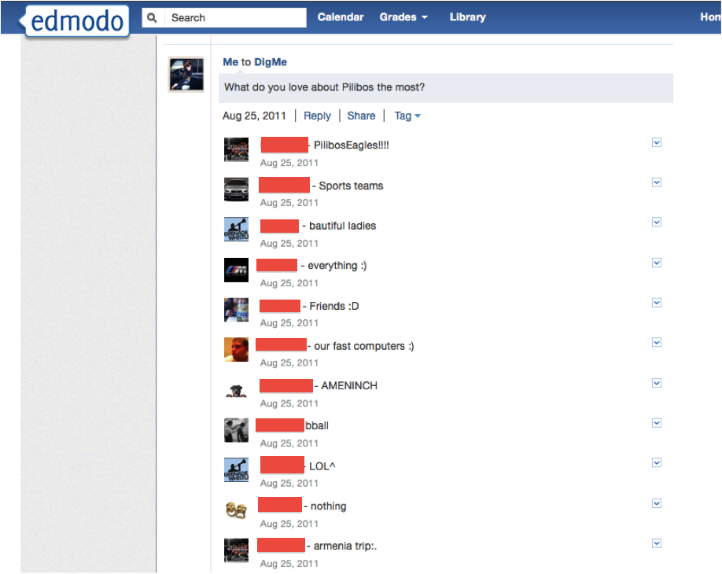
Figure 1.2 Screenshot of student responses to a basic question asked to instigate usage of the site.

- Step 4: Once students felt more comfortable with using Edmodo, I stepped up the game by adding and integrating classroom activities and eventually learning components into this now accepted social medium. Students were smart enough to know what I was doing. They were not completely fooled into thinking the use of the site was completely their choice; they still knew that participation was part of their grade. However, they did not seem to mind as much because they were using Edmodo regularly to hand in assignments and receive clarification on instruction, and what’s more, they could do it from home on their own time. It was actually making things easier for them and even if I lost their interest in class that day, I was able to pick up on it later in the day while they were home, more focused, and separated from their friends.
EVIDENCE:

I collected information from my students through Edmodo about their likes and expectations from the class. I also collected information about each student in terms of his or her capabilities. By eventually having students “hand in” their assignments through the assignment tool on Edmodo, I was able to instantly see the extent of their knowledge and capabilities in the technology at hand and address it accordingly. I was also able to track the timeliness of each student and how quickly they handed in their assignment.

- One of the assignments was for each student to create a blog that was a reflection of their personalities to some extent. They also had to write a few sentences about their expectations for the year. After they finished with that, they had to post the link to their blogs on Edmodo so we could all go through them and make comments.

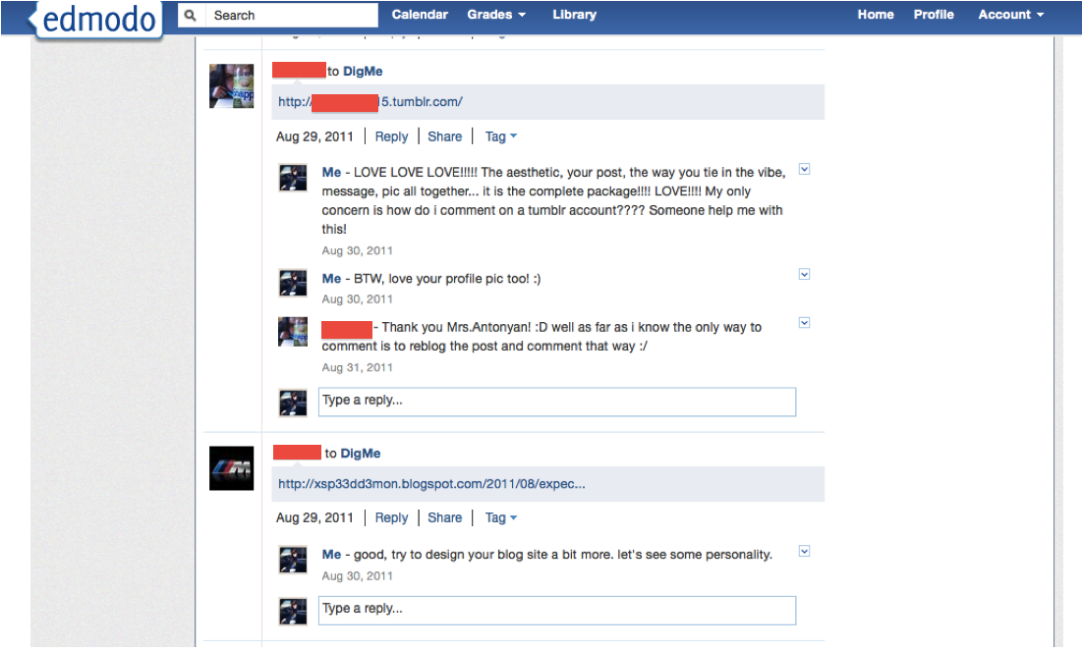
Figure 1.3 A screenshot of communication between my students and me.

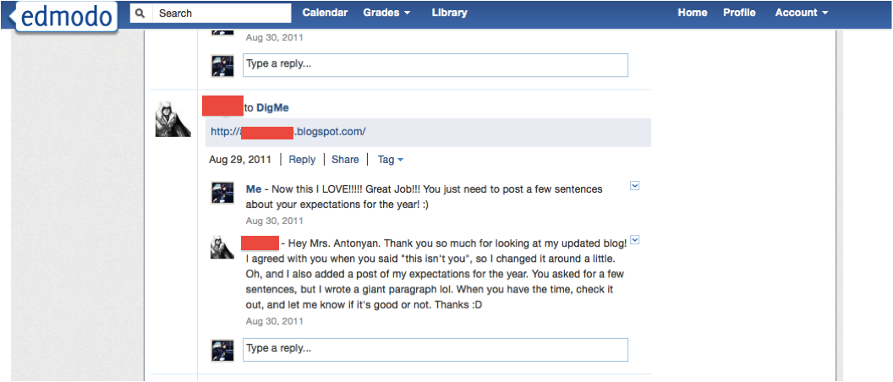
Figure 1.4 A screenshot of communication between my students and me.

By posting the links, the entire class had access to the sites and was able to “check out” their classmate’s work and comment on it. Unfortunately, most students did not comment on other students work at this point. When I asked them as to why there was no dialogue, their responses ranged from “I don’t know,” to “ I had nothing to say.” However, when we critiqued these blogs in class as a whole, viewing each one on a projector and screen, they all had comments and opinions on what they liked and how they would do things differently. At this point, students did not see Edmodo as a comfortable avenue of communication with each other.

- Another assignment the students had was to create a two-minute movie about them. I did not give too much direction so as to encourage them to figure things out for themselves. But also, I wanted them to be somewhat unsure and have questions to ask so they may use Edmodo from home when they felt unsure or stuck at a certain point in the project. I let them know that using Edmodo was an option, and I was eager to see how many actually took advantage of it. Figure 1.5 is an example of a student asking for help in regard to this assignment.
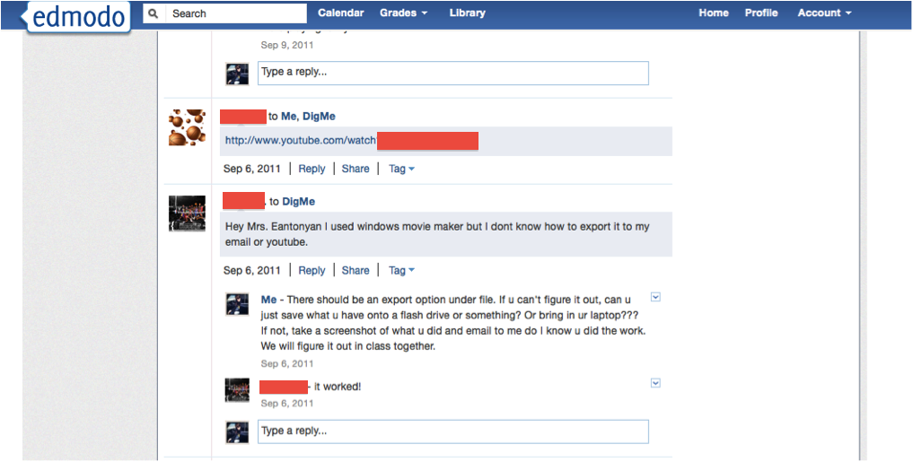
Figure 1.5 A screenshot of a student asking for help with an assignment.

Unfortunately, there were not too many questions asked through Edmodo about this assignment. Either students did not really need help with the assignment, or they still did not think of Edmodo as a viable option of communication at this point. I asked students in class why they did not use Edmodo to communicate, and most of their answers were that they did not need help. However, after they presented, it was obvious to me that some of them could have used some direction. The Table 1.3 depicts the usage of Edmodo in regards to this assignment. Out of 24 students, 8 utilized Edmodo.

Table 1.3 Usage of Edmodo by students to seek help for their video project.

However, students did use Edmodo to hand-in their assignment with the exception of one student who received a failing grade. Students had to "hand in" the assignments through Edmodo. If you look below at Figure 1.6, the title "Assignment #6: Personal Video" you will see a box marked Turned in (23). If I click on that, it takes me to the list of students who handed in their assignments. From there I can view the assignments, grade them, and the students would be aware of their standing in the class immediately.

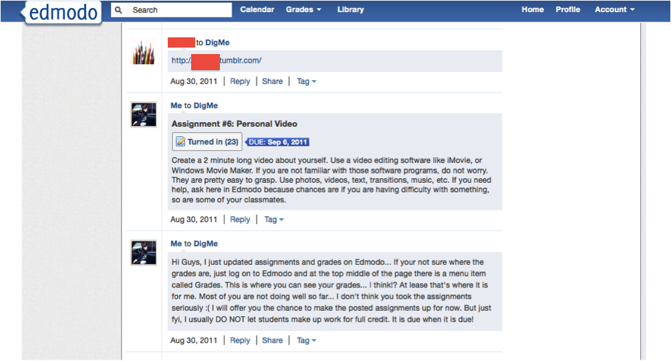
Figure 1.6 A screenshot of students “turning in” their assignment.

EVALUATION:

I evaluated the outcomes of the Edmodo posts, assignments, questions, etc. on a case-by-case basis. Each question and/or post served a different purpose and was evaluated accordingly. For example, when students were asked what their expectations were in the class, I took their answers into consideration and designed the class around their interests. When students were asked to hand in an assignment, their timeliness, correct format, and accuracy was used to grade them.
In this cycle, I wanted to measure two specific things, student engagement and student accountability.
- I measured and quantified student engagement at this point through the number of posts, responses, and feedback on Edmodo. The class was small enough to manually go through and disqualify responses like “ya”, “cool”, or “I agree”, and concentrate on more substantial posts and responses that contributed to the class and provided help to other classmates. Then I decided not to disqualify and posts, rather to label it and see how much students are using Edmodo for personal amusement and how much they are using it for furthering their achievement in the class. Table 1.4 is a summary of the quality of posts and usage of Edmodo. It is obvious that when the teacher is asking for a response, students are more apt to respond and post rather than when left to their own devices.

Table 1.4 Summary of the percentage of posts and responses by students.
- I measured and quantified student accountability based on the number of assignments that had to be handed in via Edmodo, compared to the number of assignments that had to be handed in hard copy. The difference between the two was staggering. Even though students are used to handing in paper assignments, they were more apt to “turn in” their work via Edmodo on time, rather than turn in their paper assignment. There was always an excuse of forgetting it at home, in their locker, etc. Table 1.5 compares the turning in of assignments rate of the two formats, digital or paper.

Table 1.5 Comparison of turning in homework via Edmodo and hard copy

REFLECTIONS:

When deciding what to focus on as my Action Research, I knew I wanted to integrate Social Media into my research because it is such a prevalent part of our society, and it is such a prevalent part of students’ lives. A lot of times, it seems that the amount of time students spend on Facebook, Twitter, and Instagram far exceeds the time students spend on their assignments. What movie they saw, which restaurant they ate at, their favorite songs or videos are things they post on social media sites and a lot of times their friends comment on these kinds of posts. Social media is here, it is being used, and it seems to be quite powerful. So in my first cycle, I decided to hone some of the power of social media into the classroom, and see if I could somehow draw students in and make them more interested, intrigued, involved, and concerned about the class.

I thought by introducing Edmodo in my class, I could harness the power of social media and engage students into lessons like they had never experienced before. From my experience, the over achievers will continue to achieve regardless of the conditions of the class they are in. But what about the average and the not so average students? I wanted to see if Social Media could somehow play a role in waking up these students, engaging them, holding them accountable, and actually exciting them about learning. My goal was to make Edmodo part of the class without them realizing it. At first it seemed to work pretty well. Students responded to the "casual" questions, quickly and with ease. However, when I began to ask students to hand in assignments and geared the use of Edmodo more toward class work, their interest wavered. However, as soon as students noticed that their grades were dropping, and that their performance was somewhat measured through Edmodo, they soon began participating again.
I believe that when left to their own devices, students take the easy way out usually. However, if there is some external factor holding them accountable to their work, like a teacher, grades, progress reports, or a social media site tracking their progress, then they will perform. My goal however, was to have students perform regardless of these external factors. I wanted them to feel comfortable enough and motivated enough to participate and perform. What was the missing element? Yes, if they participated they would get the credit; however, there was nothing past that encouraging them to do so. In a way they had nothing to gain (aside from a grade), no real advantage past their grade really drawing them in. My first cycle was a good start in establishing the idea and use of Edmodo; however, I need to think of a way or ways to better utilize all Edmodo has to offer. I do not want Edmodo to be another “have to” element of the class. I want it to be a “want to” element.

In my next cycle, I plan to further explore various ways to draw in the students so they feel like they are there by choice and actually need to use Edmodo to get to the next step of the assignment. I want the use of Edmodo to be “their own idea”.

I think there are so many possibilities of having use of such a tool in the class. However, because it is such a novelty in the class how to do it is not always so obvious. It is still in the discovery stage, and I cannot wait to discover what is next.

CYCLE TWO
Will using Edmodo for collaborative work simplify group work for my students and clearly map out the duties of each group member, thus resulting in a higher quality and more collaborative end result?
_____________________________________________________________________________

ACTION:

In my cycle two, I wanted to take the integration of social media in the classroom a step further and explore its collaborative tools and capabilities. I also wanted to test how different students would approach the challenge of collaboration in different ways. To do this, I decided to assign a large-scale group project. Students would have time to work on this assignment in class, but most of the work would have to be done out of class. It remained up to the group members to decide how to go about organizing their work, communicating with each other, and working on shared files from home.

The steps I took were the following:

- Step 1: I assigned my students a collaborative project. The guidelines for the assignment were as follows:
Collaborative Assignment:
In a group of 2-3, you have to do the following:
- Invent a product or service, the newer and out of the ordinary the better! (Monday, October 31)
- Come up with a name for your product or service.
- In about 80 words tell me... Who are you? What is the purpose of your company? What is it you wish to accomplish? (November 1)
- Come up with a logo, colors, and image for your company. (November 15)
- Effectively bring all your ideas and images together. Come up with a marketing campaign that includes (December 6)
- one page ad in a magazine (text and images)
- 15 second radio spot
- 30 second TV commercial
- Step 2: I made sub-groups within our DigME Edmodo group for each group working together. They named their groups, and only the group members and I had access to the information posted there. Other group members were not able to access anything posted in these sub-groups. This way I could monitor their progress and make suggestions if need be. Also, it made it simpler to have everything for the group in one place as opposed to having all the groups post on the main page and making it difficult to find certain things when necessary. In essence, these sub-groups became a kind of shared drop box of sorts, and their main source of communication and place of collaboration.

EVIDENCE:

Groups used Edmodo to "turn in" not only their assignments, but also the progress and thinking which led to the end product. The discussions they had in regards to what they were doing, how they were going to go about doing it, and other details were also all there for me to see and evaluate. It was an interesting insight into some of the groups thinking and progress. Figure 2.1 is a screenshot of one of the sub-groups page and illustrates how much information they stored on their page and what kind of communication they had with each other.

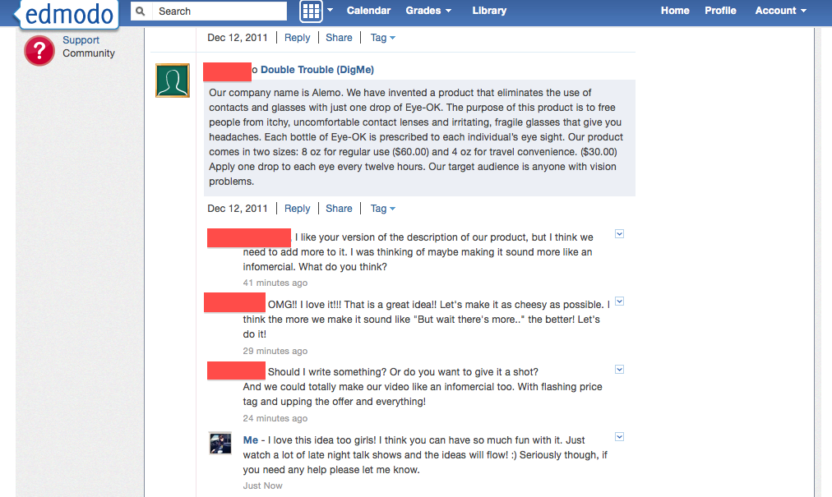
Figure 2.1 Screenshot of a sub-group and its correspondence/collaboration with each other and with me.

The group “Double Trouble” started off with a pretty clear idea of what their product was going to be, but a not so clear idea of how to present or advertise it. Through a short dialogue with each other, they were able to come up with an idea that they were both happy with and that I was able to comment on as well.

In addition to group members being able to communicate with each other and with me, this kind of correspondence was also a great way for me to track the amount of work each group and group member was contributing throughout the process. This allowed me the opportunity to intervene and encourage certain individuals to work harder, to change direction if necessary, and any other kinds of observations as they came about.

EVALUATION:

Edmodo served as a great tool to collect, analyze, and grade the group work that was due. When students were presenting the work in class, some of them had difficulty finding their saved work on their laptops and directly went to Edmodo because they knew they had a direct link to it from there. Edmodo made their work accessible from any place with an Internet connection.

The addition of the sub-groups within our main group was beneficial as well. When each group presented, their work was all in one place and easy for them to access. It was also easy for me to review and grade their work as a group. But most of all, students were able to communicate with each other feely and privately without fear of judgment by their peers early on in the process.

Unfortunately, ease of use is not always an indicator of success. To evaluate the effectiveness of Edmodo on collaborative work in my class, I looked at the following four criteria:

- The frequency of each group members post within the sub-group.
Creating or providing a collaborative space is a good start, but is not enough. Just because I provided my students with a place to communicate and collaborate, it does not mean that all students will take advantage of the opportunity and do so. In fact some did not. At the end of the project, I went back and looked at each group’s posts and quantified the number of posts/responses each group made. Table 2.1 illustrates each of the 8 groups and the number of posts and responses they had. Some groups utilized Edmodo far more than others. Note that the groups 1,3, and 6 who had only 4-5 posts were the groups who handed in their assignment links only. There was no evidence of dialogue or collaboration seen on their group page.

Table 2.1 Frequency of group posts and interaction

- The quality of posts and responses of each group member.
Looking at Table 2.1, one might think group 5 utilized Edmodo best and probably was most successful as a result. But that was not necessarily the case. I went back and qualified each post as ‘significant to the assignment’ or more of a ‘social kind of interaction’. Table 2.2 illustrates that it was in fact a tie between Groups 4 and 5 that had the most significant quality of posts.

Table 2.2 Significant Posts by groups

I tried to understand why some groups posted and responded far more than others, and I also tried to understand why some group’s quality of posts/responses seemed far more significant than others. After a brief informal survey, I realized there were a few key factors involved. First off it had to do with the group members. One of the groups consisted of two students who have really been doing the bare minimum in order to just pass. Another group consisted of two friends who apparently got into a big argument at the start of the project and could not seem to get over their differences; therefore, communication was at a minimum. It was because of such like things that made the groups differ significantly in their involvement and use of Edmodo for this assignment.

- My own evaluation of the end product based on the correspondence on the group’s page.
The next step was to evaluate the quality of the work and see if there was any real correlation between the end product and the number and quality of posts and responses. I first evaluated the end product and graded each group on their quality of work and how well they followed the directions of the assignment. Then I went back and looked at their posts and correspondence with each other to see what kind of things they were communicating about. Were their posts just links to things? Were they just deciding on what direction to go with the assignment? Or were they actually editing and actively working on their project via Edmodo?

With the exception of group 1 and 3, most of the groups did very well. But it was no surprise that it was group 2, 4, 5, and 8 who received an A on their assignment. Not only did they communicate more often than the other groups, the kind communication was relevant and “showed the work.”

- Feedback from a student survey.
At the end of the assignment and at the end of the semester, I had the students take a short survey about their experience with Edmodo in relation to this assignment. I asked them only two questions:

1. Did you find Edmodo a helpful tool in the assignment?
2. Do you think it would have been easier to complete the assignment without the use of Edmodo?

Table 2.3 documents the results of the survey. Most students found Edmodo a useful tool and thought it made completing the assignment easier. Only 4 students were generally ambivalent about the use of Edmodo. However the same 4 students have had an ambivalent attitude toward the class in general.

Table 2.3 Student Responses to End of Semester Survey

REFLECTION:

After Cycle One, I was determined to find more uses for Edmodo than just as a social forum with the edition of a gradebook feature. I know I purposely started off slow to get both myself and the students accustomed to the use of Edmodo as a part of the class, but I felt like there was more to it that I needed to explore. I thought long and hard about what the true purpose of Edmodo might have been when creating it. My thoughts immediately went to the idea of collaboration. So I began to think of ways to use Edmodo to encourage collaboration and see exactly how successful it would be in that effort.

I thought that both collaborating on a project and contributing to the class in some way, would encourage usage of Edmodo, and in turn, engage the students further into the class. The entire idea of my Action Research was to see how I could draw students into their lessons more and genuinely have them want to work harder and do better.

Using Edmodo for group projects and creating sub-groups within our class definitely made things easier and quicker to work on and access. However, more than that, what Edmodo truly provided was an opportunity for students to become more invested in their work and to take charge in getting to the next step. I simply gave them the assignment and told them they could use Edmodo as a means to communicate with each other. Some groups did not fully utilize Edmodo to its fullest potential. However, some did. They used it as a place to communicate their ideas, receive feedback on their progress from me, and work on files from home and school, and any other place they needed to. A majority of the class used Edmodo voluntarily and at their discretion to get the assignment done. But of course there are always some students who do not utilize tools at their disposal or do they care to deviate from what they are used to.

All in all, I think Cycle two was in line with my expectations. I knew which students would not really take advantage of Edmodo based on their work ethic and past behavior and attitude. The rest did take advantage of Edmodo, some in its basic form (collecting assignments for grading purposes) and some on a higher level (communicating, editing, collaborating). I look forward to continuing the use of Edmodo for collaborative and other assignments.
At this point, thinking about Cycle Three, I want to see how I can take all of this to the next step. I can definitely give the students a new assignment to work on, but I am thinking of exploring another aspect of Edmodo in the classroom. I will have a co-teacher in this class who will be teaching the students specifically about photography. I want to incorporate the presence of this new teacher into the class and see how we can use Edmodo as a means of communication with each other and the class and perhaps even utilize Edmodo as a class management tool.

CYCLE THREE

If I use Edmodo as the main form of communication between a co-teacher and myself in my Digital Media class, will I be able to successfully manage communication and collaboration between teachers and with the class?

______________________________________________________________________________

ACTION:

Cycle Three somehow presented itself to me with the inclusion of a new co-teacher in my elective Digital Media class. A professional photographer, Mr. Hall, joined my class as a teacher one out of the three days of the week the class met. I had approached him at the beginning of the year for some help asking him to come in as a guest speaker, but that idea somehow evolved into him being a co-teacher at the start of the second semester. I was very excited about this change, but a little unsure of how we were going to maintain an organized and cohesive curriculum throughout the rest of the year. Communication was key and the students needed to always know that we were on the same page and following the same guidelines for the class.

I decided to use Edmodo as our main form of communication because it would not only serve its purpose of keeping correspondence with each other and letting each other know what was happening next in class, but it would definitely let the students see first hand what we were communicating, what the other teacher expected, and they would not have any way of spinning the truth or playing teachers against each other.

We decided that we were going to do the following:

- Step 1: Add Mr. Hall to our Edmodo group as a teacher who would be able to administer assignments, add grades, and assign badges.

- Step 2: Both Mr. Hall and I would use Edmodo to clearly state and assign all assignments so the other teacher would always be aware of what was going on and expected of the class. The first few classes, I joined Mr. Hall during his lectures, but after a few meetings, I was unable to go to every class. As a result, it became increasingly difficult to keep track of what he did in class and what he expected. So he began to post a recap and the assignment on Edmodo, not only to remind the students of what they had to do, but to also keep me in the loop. I would use this information the next class meeting to remind students and to continue off of his lesson and somehow incorporate it into my own lessons. In turn, I would do the same and he would be able to decipher exactly where the students were in my class.

What is more, students saw this interaction and knew for a fact that we were both on the same page. A lot of times students like to spin situations around and say “but that is not what was said”, “I didn’t know”, and so on. By having our communication via Edmodo, it was there for students to see and know that the other teacher was always aware of what was going on.

- Step 3: We would use Edmodo to track student progress by commenting on assignments, adding grades in the gradebook, and using another feature of Edmodo which I had not used up until this point, assigning badges.

The use of badges has gained popularity in recent years and it seems to work well with students who are so used to social media sites. The assignment of badges became a fun addition to the class that the students enjoyed and competed for, and it helped both teachers know how each student was doing in the other’s class.

EVIDENCE

As Mr. Hall and I proceeded with the class, we realized exactly how different our curriculum actually was. His portion of the class concentrated on photography only. He gave lectures about composition, lighting, shutter speed, etc. and gave students a chance to take some pictures at the end of each class meeting to experiment with the lessons he covered. In the end, he also assigned the class a final project that was not part of any project or assignment I had planned out for them.

My assignments were more hands on and things they had to figure out for themselves. In addition, my assignments during the second semester were all geared toward the completion of our yearbook. Even though Mr. Hall and I were teaching one class, it started to feel like we were teaching two different classes. This became an issue when we started to administer grades. So we made sure that we would communicate even more via Edmodo to ensure we maintained some sort of correlation between our classes. The posts we made were anything from class assignments, to reassertion that work would be collected, to critiquing work if necessary. Figure 3.1 is one example of our communication with each other.

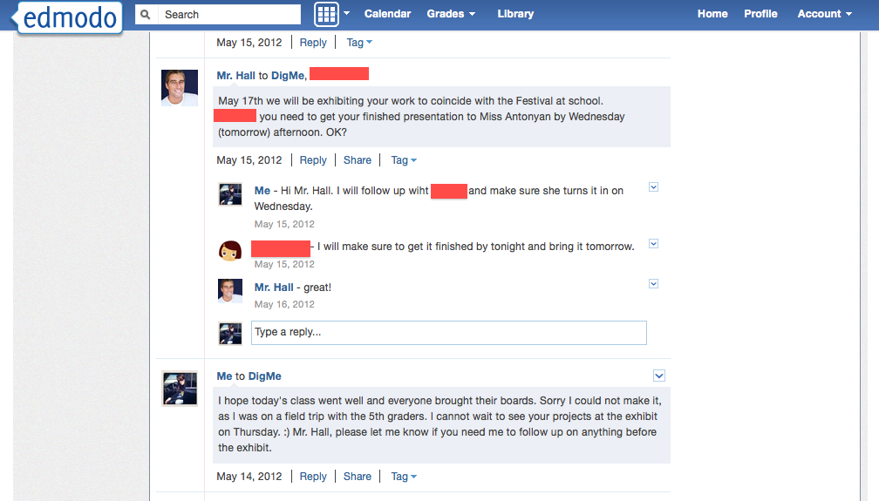

Figure 3.1 A screenshot of Mr. hall communicating with a student and me. I intervened and made sure a student turned in the work on a day that Mr. Hall would not be present.

Mr. Hall really took to Edmodo, using it often to ask the students to bring materials to class and reminding them of assignments. This was especially important for him as he only met with students every Monday and they would forget what needed to be done in one weeks time. Figure 3.2 shows Mr. Hall communicating with the class and asking them to come prepared the following week.

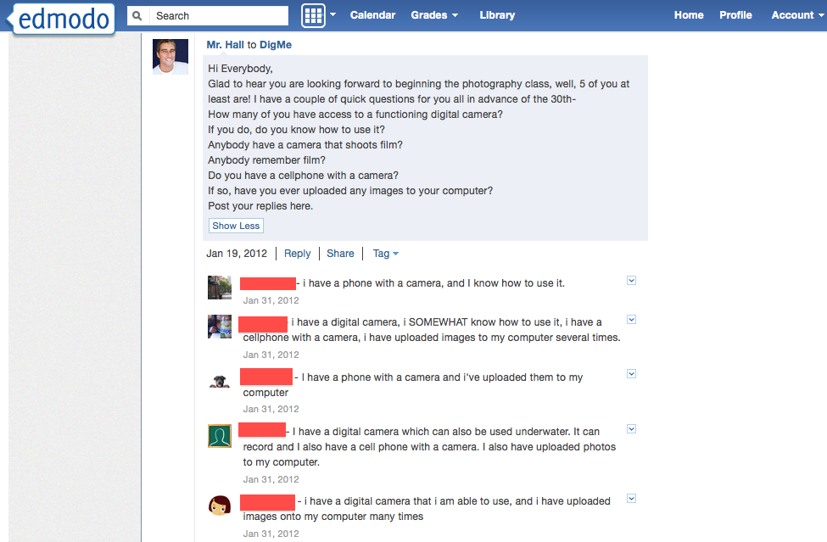

Figure 3.2 Student responses were quick and many at the start of Mr. Hall’s inclusion into the class.

In addition to communicating with the class, we began to use Edmodo to keep track of behavior and progress of students in each other’s class. We did this one of two ways:

- Through tracking posts.

We could see what the other was writing to the students and knew how those students were performing overall. For example, in Figure 3.3, a student tried to pass off a Google link as an assignment for Mr. Hall’s class. The same student was trying to get away with the bare minimum in my class as well. Seeing his carelessness in the photography class only reasserted the fact that this student was not taking the class seriously and was not working the way he should have been.

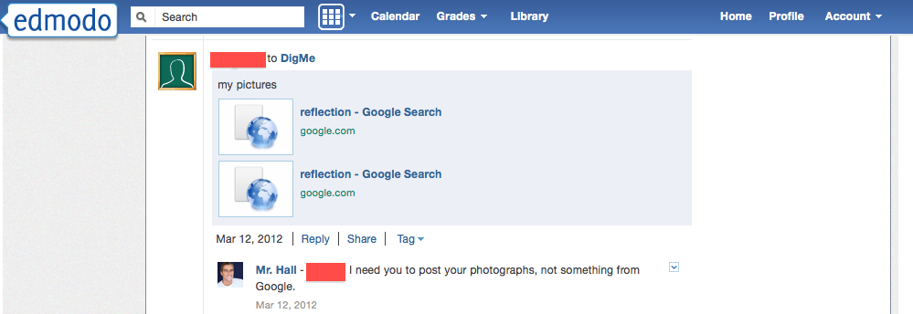

Figure 3.3 A screenshot of a posted assignment by a student trying not to do the assigned work

- Through the use of badges. Each of us would assign a badge to students who deserved it for performing certain tasks or achieving certain goals. Some received badges for their great performance, asking a good question, being a hard worker, being a participant, etc. This would show the other teacher, which students were active in the class and which were not. Also, those students who did not get any badges would be singled out as the students who were not participating or contributing enough to the class.

After awhile, receiving a badge became a sort of game with the students, which in turn made them more and more competitive, trying to do certain things in class and performing at what seemed at a higher level to receive more badges. Figure 3.4 and 3.5 are examples of two different students who received badges for a variety of reasons. Figure 3.6 is an example of a student who did not receive any badges as he was not working properly in class.

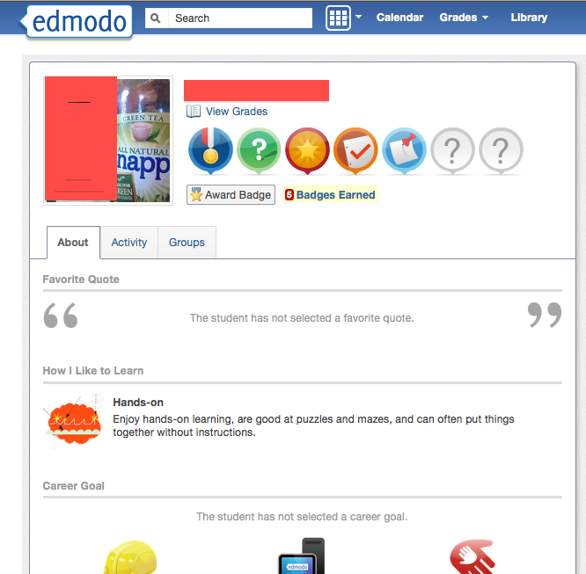

Figure 3.4 A Screenshot of a student who received 5 badges for her exemplary work in class. I gave some of the badges and the photography teacher gave some.

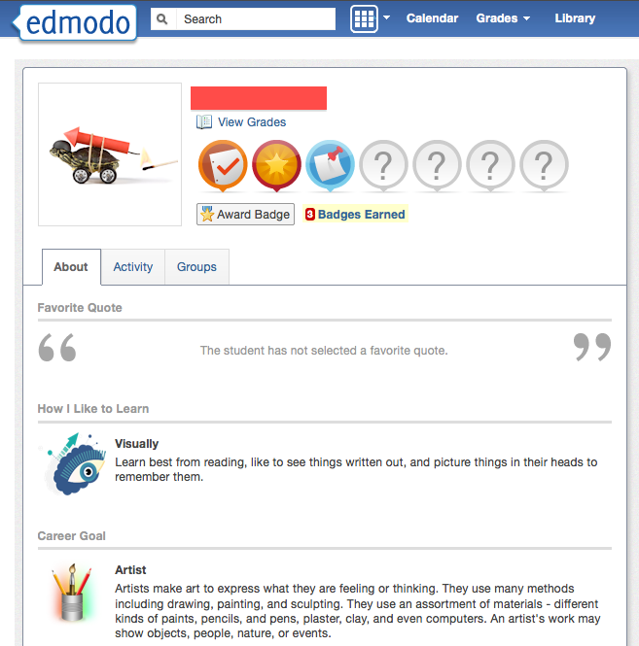

Figure 3.5 A screenshot of a student with three badges. She did an overall good job, but did not really work as hard as she could have. There was no extra effort, therefore, she did not receive any extra badges.

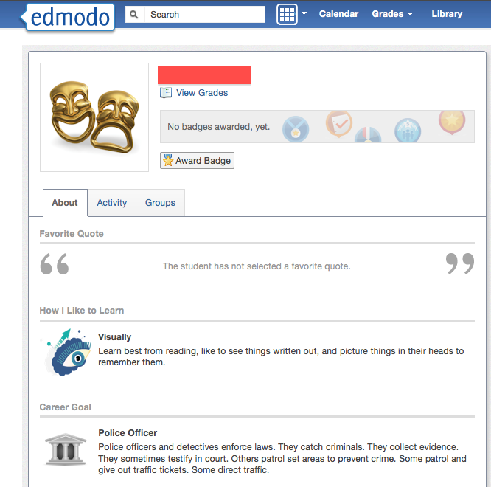

Figure 3.6 A screenshot of a student who did not earn any badges.

EVALUATION

The integration of a new teacher in the class was both a pleasure and a challenge. Having a new perspective in the class was a great addition, but maintaining organization, communication, and consistency definitely was something to be dealt with.

We utilized Edmodo greatly, conveying to each other what we expected from the class, the students, and setting up guidelines that were not only clear for all to see but consistent between teachers.

However, that was my impression. After a short interview with Mr. Hall, I managed to receive some feedback on Edmodo and his impression of it in accordance to the class. Mr. Hall said, “I thought Edmodo was really a neat tool. It reminded me very much of Facebook, which the kids are all so used to. But I have to say I really think it helped us out in the class as teachers. How else were we going to convince the class that we meant business and were going to track their work? Thanks for introducing me to it! If we teach this class again next year, I definitely think we need to use it again, especially the badges. Those worked out great!”

While Mr. Hall’s impression was very positive and encouraging, I also needed to get the students impressions as well. I administered a survey at the end of the year to the students to get their feedback. I decided to ask some general questions about the class to see if they mentioned Edmodo on their own or not, and then I asked more specific questions about Edmodo and its use in the class.

I asked the following questions:

- What is your future area of interest? (Medicine, Law, business, technology, design, etc?)
- Since this class is an elective, why did you pick this class over the others offered this year?
- If you could, would you take this class again next year? Why?
- What was your favorite thing about this class?
- If anything, what would you definitely change about this class?
- What would be one recommendation about this class for next year?
- Did you like the introduction of Edmodo into the class?
- Did you find Edmodo useful as part of the class? If yes, how? If no, why not?
- Do you think you would have performed differently or at a different pace if Edmodo was not part of the class?
- Did you consider the addition of Mr. Hall’s photography class an asset to the Digital Media class? If yes, why? If no, why not?
- Did you feel Mr. Hall and I communicated with the class effectively and consistently about what was expected?

In order to properly analyze the responses I received from these questions, I had to first code the data and set up guidelines that would help validate my interpretation of the data.

- I wanted to focus on students’ responses, however, there were students who participated in the use of Edmodo far more than other students. So I went back and manually counted the number of times each student posted, responded, or turned in an assignment. I wanted to focus on responses from the students who actually took part in the use of Edmodo in a substantial way. I split the data into two groups, students who participated in activities on Edmodo over 40 times and those who participated less than 40 times over the span of one academic year. With a total of 24 students in the class, 19 of them participated over 40 times and 5 of them had less than 40 posts.

- I then set up criteria to look for in their responses. I thought about what words or phrases would demonstrate students’ acceptance of Edmodo as a viable tool for communication and its usefulness/importance as part of the class. I decided to look for the words Collaboration, Communication, Simple/Useful, and Share.

- After reading all the students responses, it was evident that Group 1, the group that used Edmodo more than 40 times found Edmodo far more useful than the group that did not utilize it as often.

DATA | Collaboration | Communication | Simple/Useful | Share
Group 1 > 40 | 8/19 = 42% | 18/19 = 95% | 19/19 = 100% | 13/19 = 68%
Group 2 <40 | 0/5 = 0% | 4/5 = 80% | 2/5 = 40% | 1/5 = 20%
Both Groups | 8/24 = 33% | 22/24 = 92% | 21/24 = 88% | 14/24 = 58%

Table 3.1 Survey Results at the end of the year

Looking at the above responses in Table 3.1, it is clear that students overall saw Edmodo as a good tool for communication and also thought it was simple and useful. A little more than half the class also saw it as good way to share ideas and files. What was interesting was the word collaboration was not mentioned as much, only 42% of Group 1 mentioned it and 0% of Group 2 mentioned it. After further analysis, I hypothesized that the reason why it was not mentioned too much was because students of this age are not too familiar with the word, thus did not mention it. When I went back and read their responses again, I noticed that a few more described the idea of collaboration without actually using the word. They used phrases like “we worked together,” “we came up with the idea, “ etc. When analyzing those phrases in the context of the work we did in class, it is obvious that students were referring to collaboration. In the end, the number rose to 16/24 students who mentioned the idea of collaboration bringing the total percentage to 67% of students who saw Edmodo as a collaborative tool.

REFLECTION

In Cycle Three, the use of Edmodo shifted from just teacher/student to teacher/teacher/student. The idea of using Edmodo as a communication tool and a place for collaboration in a class was expanded to include another teacher, administrator on the Edmodo group, thus adding another dimension to the Action Research.

If the new co-teacher did not join my class, I would not have explored the idea of adding more teachers to the group. The idea would probably have been something I explored at a later time, in a 4th or 5th cycle. During this process, I was able to see how Edmodo could serve as a pretty powerful tool not just between teacher and students, but between two teachers. It was used in many ways, as a tool for communication, collaboration, planning, organizing, keeping track of assignments and grades, and even functioned as a shared reward system by the teachers for the students.

In Cycle Three I wanted to see how effectively two teachers could manage a class with somewhat different views and ideas of where the class should be headed. It is not that we had a difference in opinion, but that we had different visions of what our end project would be. Therefore, the class content for both of us was quite different. Students actually felt like they were taking two different classes because of the content; however, we managed to maintain solidarity and not confuse students with different levels of expectations, rules, and guidelines. Edmodo really helped clarify and map out to students, and even the two teachers, what the class was about and what was truly expected of the students.

I was eager to see how Edmodo, what seemed like a simple social media site, could actually serve different purposes at different times in the class. At the start of Cycle One, we used it mainly for communication and assigning and turning in assignments; then during Cycle Two, it evolved into a collaborative tool for group work; in the end, during Cycle Three, it became more of a management tool between two teachers trying to maintain a consistent and organized class.

The end of Cycle Three marked the end of the Digital Media Class for this year and the end of my Action Research. However, this is anything but the end. It seemed to me that every time I thought this was all Edmodo had to offer, I would discover another aspect of it that added more depth and dimension to my research and opened up more possibilities of how students can learn and communicate with each other. I am eager for the start of next year as I am more accustomed with Edmodo and can jump in headfirst and begin to discover new and exciting ways it can contribute to student learning.

FINAL REFLECTIONS

As my Action Research comes to an end, I look back at this year and cannot believe all the things that were accomplished in such a short period of time. Through my Action Research, I did not only learn about Social Media in the classroom and its impact, but I learned a great deal about myself and what I value and consider most important as an individual, a teacher, an administrator, and as a student.

As an individual my goal has always been to strive for change. I am never satisfied with the status quo or things being good enough. I easily get restless and look for some new project to work on or work toward. I now realize that this trait of mine does not really have much to do with being restless. It has to do with realizing that remaining stagnant and accepting things for the way they are or have always been is not good enough. I now see that the reason I have always strived for change is because I wanted or even needed to experience new things and make up my mind accordingly. Like Dewey and Constructivist theorists, I believe I have a need to take part in the process of learning and discovering what is to come next. I have to be a part of the process, a part of the discovery, a part of the learning, and essentially a part of the change.

As a teacher, I realized that my needs and values were the same as an individual in the sense that I strive for change; however, the need for change stems from a different place. It is not that I need to experience new things necessarily, as much as it is that I want to make change in students’ lives. I would love to be remembered as compassionate, knowledgeable, capable, but most importantly as someone who made a difference. I think that has always been my main draw to the field of education. There are other fields that pay more, offer more benefits, are far more glamorous, and so on. But for some reason, I have always been drawn to and drawn back to (after leaving the field for a short period of time) the field of education.

I now realize that as a teacher I have the power and the ability to bring about change not only by “teaching” my students but by empowering them to discover and experience change for themselves. During my Action research, I saw myself evolve from a teacher who lectures and presents material, to a teacher who provides opportunities for students to actively map out and take part in their education. When I involved my students in my Action Research I realized that I was not just teaching them a new way to communicate and collaborate, but I was creating leaders, thinkers, and collaborators who took charge of their own learning at times, for no other reason except that they could. They were given the opportunity to contribute, and they did. And as a result, they brought about change in our class and in the way they approached their studies.

As an administrator, the change that I seek is not so much about me as an individual, or me as a teacher, but the change I seek is all about my school, my students, and my community. Instigating change ceased to be about me, rather became about ‘the me’ that was a part of the greater whole. I realized that change was not something I was in charge of or responsible for as much as it was a shared process among teachers, administrators, students, and even parents. Without some kind of common vision, common goal, and even shared work, change is much harder to bring about than necessary. Yes, this year I was able to create a new class, bring in social media into the class, start planning for a new Art Program at our school, started planning and organizing other major changes within the school, but most importantly what I was able to do was align these changes with common values between myself, my principal, my students, and other teachers. I used their knowledge, their experiences, and made everyone work toward a common purpose, and by doing so, I ended up with an end product I could not have even envisioned on my own. The various perspectives added dimension to my original ideas and proved that the greater whole can definitely accomplish more than any one person.

As a student, I believe I have learned and changed the most. I started off this program an eager and excited student ready for a change and a new challenge. I was eager to learn and know new things. I was eager to experience what it really meant to be grad student. Instead what I really learned was that I will never be done learning. I learned that if I want to create change and make a difference, that I will be forever a student, learning and knowing that I still do not know enough. What I also learned was that I cannot learn just on my own. Working cooperatively and sharing knowledge with my students, teachers, and principal can only enhance any learning that may be taking place. I always saw myself as an individual who would work hard and bring about change. Now I know I can bring about change, but I should not be doing it alone. Bringing in different perspectives and ideas will only enhance and add to what it is that I am trying to accomplish.

This program has enabled me to look at things that matter to me through different eyes. At this point, I can look at my work and all I hope to accomplish as a small part of a larger whole. If there is anything that this program has taught me, it is that the collective whole, the community, the group of like minds and goals, can and will accomplish more and accomplish it far more effectively.

It is only fitting to end off my final reflection with a quote from Helen Keller that sums it all up, "Alone we can do so little; together we can do so much."

REFERENCES
Johnson, D.W., & Johnson, R.T. (2007). Cooperation and the use of technology. In J.M. Spector & M.D. Merril & J. Van Merriënboer & M.P. Driscoll (Eds.), Handbook of research on educational communications and technology (pp. 401-418). New York, NY: Taylor Fracis Group.

Smith, Frank (1998). The book of learning and forgetting. New York, NY: Teachers College Press

Dewey, John (n.d.). Democracy and education. Retrieved from http://www.gutenberg.org/files/852/852-h/852-h.htm#2HCH0009

Devidove, E. (2010). Get serious about social learning by focusing on what matters. Learning Solutions Magazine. Retrieved from http://www.learningsolutionsmag.com/articles/591/get-serious-about-social-learning-by-focusing-on-what-matters

Holland, C. & Muilenburg, L.Y. (2011) Supporting collaboration: Edmodo in the classroom. Retrieved from site2011edmodopaper_1_holland_muilenburg

Bradley, A.J. & McDonald, M.P. (2011) Social Media versus Knowledge Management. Harvard Business Review. Retrieved from http://blogs.hbr.org/cs/2011/10/social_media_versus_knowledge.html

